Small Group Guidelines
- Keep your sharing focused on your own thoughts, feelings, and actions. Please limit your sharing to three to five minutes.
- There is NO cross-talk please. Cross-talk is when two people engage in a dialogue during the meeting. Each person sharing is free to express feelings without interruptions.
- We are here to support one another. We will not attempt to “fix” one another.
- Anonymity and confidentiality are basic requirements. What is shared in the group stays in the group. The only exception is when someone threatens to injure themselves or others.
- Offensive language has no place in a Christ-centered recovery group.

Accountability Team Phone Numbers

Sponsor

Accountability Partners

© Celebrate Recovery®
Celebrate Recovery®

CO-DEPENDENCY

The Problem and Solution

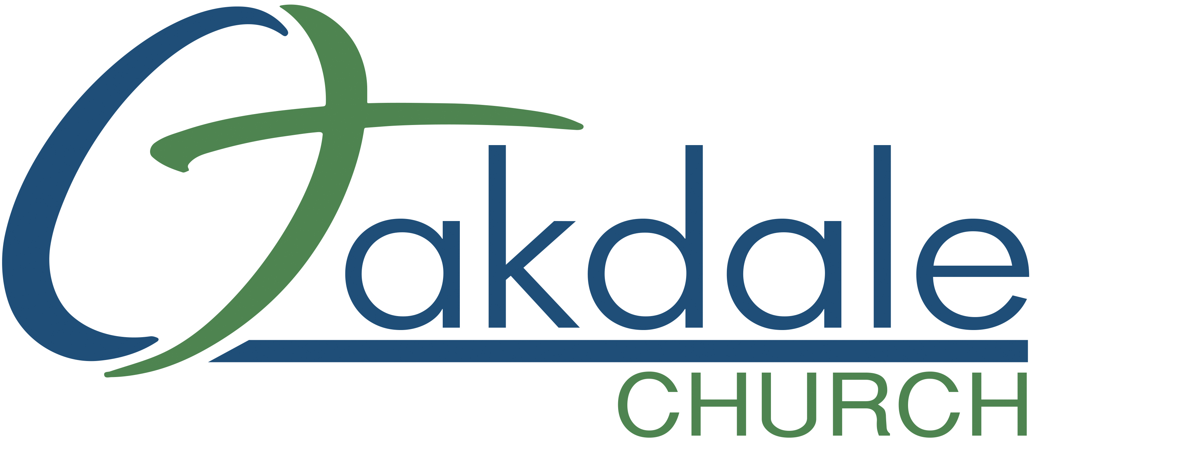
3425 Emory Church Rd, Olney, MD 20832
oakdale.church/cr
The Problem
In the broadest sense, co-dependency is when a person’s need for approval or validation from another person allows them to be controlled or manipulated. They are willing to compromise their own values, choices, and behavior at the expense of their personal well-being.

Characteristics of someone struggling with co-dependency may include, but are not limited to:
- Assuming responsibility for other’s feelings and behaviors.
- Feeling guilty about other’s feelings and behaviors.
- Having difficulty identifying or expressing one’s own feelings.
- Minimizing, altering, or denying how one truly feels.
- Worrying about how others may respond to your feelings, opinions, and behavior.
- Valuing others opinions and feelings more than your own.
- Feeling embarrassed when receiving recognition, praise, or gifts.
- Living with messages of not being good enough, valued, or loved.
- Fear of expressing different opinions or feelings from those of others.
- Fear of being hurt and/or rejected by others.
- Compromising one’s own beliefs, values, and integrity to avoid other’s rejection or anger.
- Over-functioning to be needed, valued, or loved.
- Tolerating mistreatment or abuse from others while justifying their behavior and trying to defend them.
- Overly caring for others at the expense of one’s own self needs; feeling victimized and “used” as a result.
- Anxiety in saying “no” to someone, even when saying “yes” would be at great inconvenience.
- Directly or indirectly attempting to fix, manage, or control another person’s problems to help them avoid feeling bad or experiencing the consequences of their choices.
- Judging everything you think, say, or do harshly, as never being “good enough.”
- Feels conflicted by a desire to be needed and resentment for feeling obligated in serving others.
- Being extremely loyal, to the point of remaining in harmful situations too long.
- Feels bound in relationships by performance (what I do) rather than core value and worth (who I am).
- Avoids conflict with other people to the point of being unable to speak true feelings or asking for valid needs to be met, oftentimes countered by fits of anger or rage.
The Solution
Freedom from co-dependency begins when we surrender the illusion that our identity and value are established through the lenses of other people. Our identity is in how God views us and who He created us to be. As a result, we no longer need to see ourselves as a function of what we do, but who we already are.

Sobriety for the co-dependent is different. It is not characterized by abstaining from a substance. It is more relational in nature. Co-dependent sobriety is a process distinguished by the following:

- Working through the 8 Recovery Principles and 12 Steps Principles as a part of a CR Step Study and learning to apply them to day-to-day life.
- Accepting and walking in the biblical truth that your self-worth is who you are in Christ, and not based on how others view you, what you do, or the service you perform.
- Learning to recognize and enforce healthy boundaries that accurately establish where you end and another person begins. Not allowing others to compromise those boundaries.
- Learning how to help others in suitable ways, without rescuing or fixing; allowing them to act independently, allowing them to own the results of their choices and behavior.
- Performing acts of service as a choice, not out of duty or for recognition and value from others. Serving with joy using God-given talents and abilities.
- Learning to live a balanced life where self-care and taking responsibility for one’s own health and well-being take priority over the addictive behavior and control of others.

As you draw closer to your Higher Power, Jesus Christ, you will learn how to apply the 8 Recovery Principles and 12 Steps, designed to guide you in this journey we call “Recovery.”

If you are diligent to provide willingness, integrity, consistency, and rigorous honesty, God will supply you with the courage, strength, and ability to take the necessary steps to gain freedom from compulsive behaviors.

