Small Group Guidelines
- Keep your sharing focused on your own thoughts, feelings, and actions. Please limit your sharing to three to five minutes.
- There is NO cross-talk please. Cross-talk is when two people engage in a dialogue during the meeting. Each person sharing is free to express feelings without interruptions.
- We are here to support one another. We will not attempt to “fix” one another.
- Anonymity and confidentiality are basic requirements. What is shared in the group stays in the group. The only exception is when someone threatens to injure themselves or others.
- Offensive language has no place in a Christ-centered recovery group.

Accountability Team Phone Numbers

Sponsor

Accountability Partners

© Celebrate Recovery®
Celebrate Recovery®

GRIEF and LOSS

The Problem and Solution

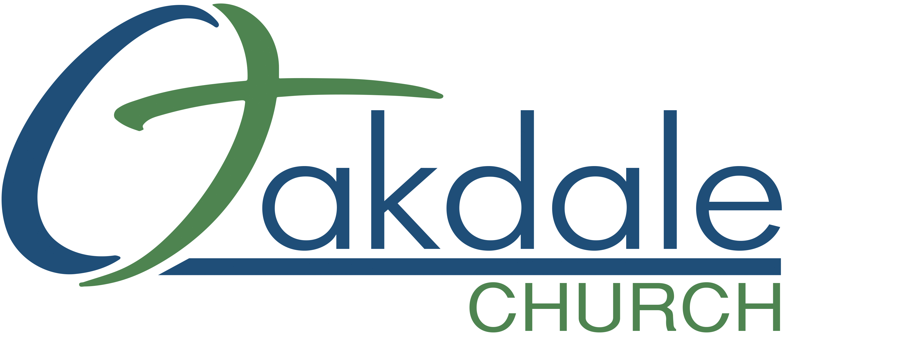
3425 Emory Church Rd, Olney, MD 20832
oakdale.church/cr

Types of Loss
Death of a loved one, end of an important relationship,
loss of independence through disability, ambiguous loss
through traumatic brain injury or dementia, miscarriage/
infertility, job loss, loss of a pet, loss through theft,
loss through natural disaster, loss of hopes and dreams
The Problem
- Do you feel stuck, unable to move through the loss?
• Are you unable to accept your cricumstances and find your new normal?
• Has the loss become and obsatcle to daily activities?
• Has the grief paralyzed you?
• Has the grief prevented you from maintaing meaningful relationships?
• Is the grief an obsatcle in developing new relationships?
• Do you tend to see life only through the lens of your loss?
• Has anger over the loss been an obstacle in your daily life?
• Do you feel guilty “moving” on?

The Solution
- We came to realize that we are powerless and could not
- control the circumsatncs that led to the loss.
- We understand that our problems are emotional and spiritual.
- We are ready to face our denial and accept the truth about
- our lives and our loss.
- We are ready to accept responsibility for our actions and
- make Jesus the Lord of our lives.
- We are dedicated to living a life of recovery while still honoring or loss.
- We are willing to turn to Godfor comfort in our grief.
- We are willing to begin the process of recovery and working
- through the 12 steps to heal ourselves, and start living the
- life God has planned for us.
- We are willing to find a Sponsor and Accountability Partners.

- We realize our group provides a safe place to share our fears,
hurt, or anger and is also a place to rejoice in victories.
- We are willing to face our character defects and work
through these feelings in our group.
- We are willing to take the focus off of our loss and grief on
- God.
- We are willing to believe and trust in God’s love for us, and
to see ourselves as He sees us.
- We are willing to seek a closer relationship with God.
- By facing our fears, we have realized that we need Jesus
- Christ and the Holy Spirit in our life to overcome those fears.
- As we surrender ourloss/grief to God, we will come to
know that He is all we need.

I will also be willing to:
- Form an Accountability TEAM: Sponsor, Accountability Partners.
- Weekly attending the Open Share Group.
- Commit to a daily quiet time in the Celebrate Recovery Bible.
- Read about this area of recovery.
- Understanding the root of each core issue you identify with and become willing to experience grief, forgiveness, and acceptance.

As you draw closer to your Higher Power, Jesus Christ, you will learn how to apply the 8 Recovery Principles and 12 Steps, designed to guide you in this journey we call “Recovery.”
If you are diligent to provide willingness, integrity, consistency, and rigorous honesty, God will supply you with the courage, strength, and ability to take the necessary steps to gain freedom from unhealthy behaviors.

