Small Group Guidelines
- Keep your sharing focused on your own thoughts, feelings, and actions. Please limit your sharing to three to five minutes.
- There is NO cross-talk please. Cross-talk is when two people engage in a dialogue during the meeting. Each person sharing is free to express feelings without interruptions.
- We are here to support one another. We will not attempt to “fix” one another.
- Anonymity and confidentiality are basic requirements. What is shared in the group stays in the group. The only exception is when someone threatens to injure themselves or others.
- Offensive language has no place in a Christ-centered recovery group.

Accountability Team Phone Numbers

Sponsor

Accountability Partners

© Celebrate Recovery®
Celebrate Recovery®

MIXED ISSUES

The Problem and the Solution

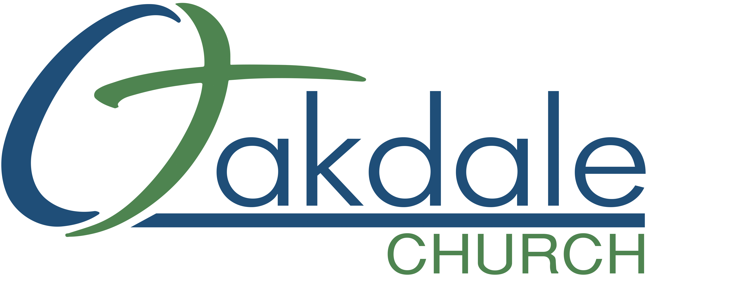
3425 Emory Church Rd, Olney, MD 20832
oakdale.church/cr
Welcome to Celebrate Recovery!

You may have come to our ministry because of a friend’s recommendation. Maybe you are here because you saw a flyer or heard an announcement here at our church. Regardless of why you decided to attend, we are SO glad you are here.

We are very excited you have decided to stick around for our Open Share Groups. We want to provide a secure environment in our Open Share Groups that keep you coming back! That is why we use the following five guidelines. These guidelines ensure that no matter what group you decide to attend, it will be an experience in which you will feel safe and supported.

These Small Group Guidelines are:
- Keep your sharing focused on your own thoughts and feelings. Limit your sharing to three to five minutes.
- There will be NO cross-talk. Cross-talk is when two individuals engage in conversation excluding all others. Each person sharing is free to express feelings without interruptions.
- We are here to support one another, not “fix” one another.
- Anonymity and confidentiality are basic requirements. What is shared in the group stays in the group. The only exception is when someone threatens to injure themselves or others.
- Offensive language has no place in a Christ-centered recovery group.

The Problem
After attending our Newcomers 101 group you may still be struggling to find the right Open Share Group for you. (The goal of Newcomers 101 is to explain how Celebrate Recovery works and to help you find an Open Share Group.)

You may have looked through our group descriptions and not found a group that specifically meets your recovery needs.
You may have looked through our group descriptions and decided that you could be in any of them. You are unsure where exactly to start.
You may feel most comfortable starting your recovery journey around others with “mixed issues”…

The Solution
Attend our mixed issues group! We are so glad to have you join us. This is a group that will help you address and begin the healing process for your hurt, hang-up, or habit. Your struggle is important to us, and we look forward to walking with you on your unique recovery journey.

