Small Group Guidelines
- Keep your sharing focused on your own thoughts, feelings, and actions. Please limit your sharing to three to five minutes.
- There is NO cross-talk please. Cross-talk is when two people engage in a dialogue during the meeting. Each person sharing is free to express feelings without interruptions.
- We are here to support one another. We will not attempt to “fix” one another.
- Anonymity and confidentiality are basic requirements. What is shared in the group stays in the group. The only exception is when someone threatens to injure themselves or others.
- Offensive language has no place in a Christ-centered recovery group.

Accountability Team Phone Numbers

Sponsor

Accountability Partners

© Celebrate Recovery®
Celebrate Recovery®

PHYSICAL/SEXUAL AND
EMOTIONAL ABUSE
FOR WOMEN

The Problem and the Solution

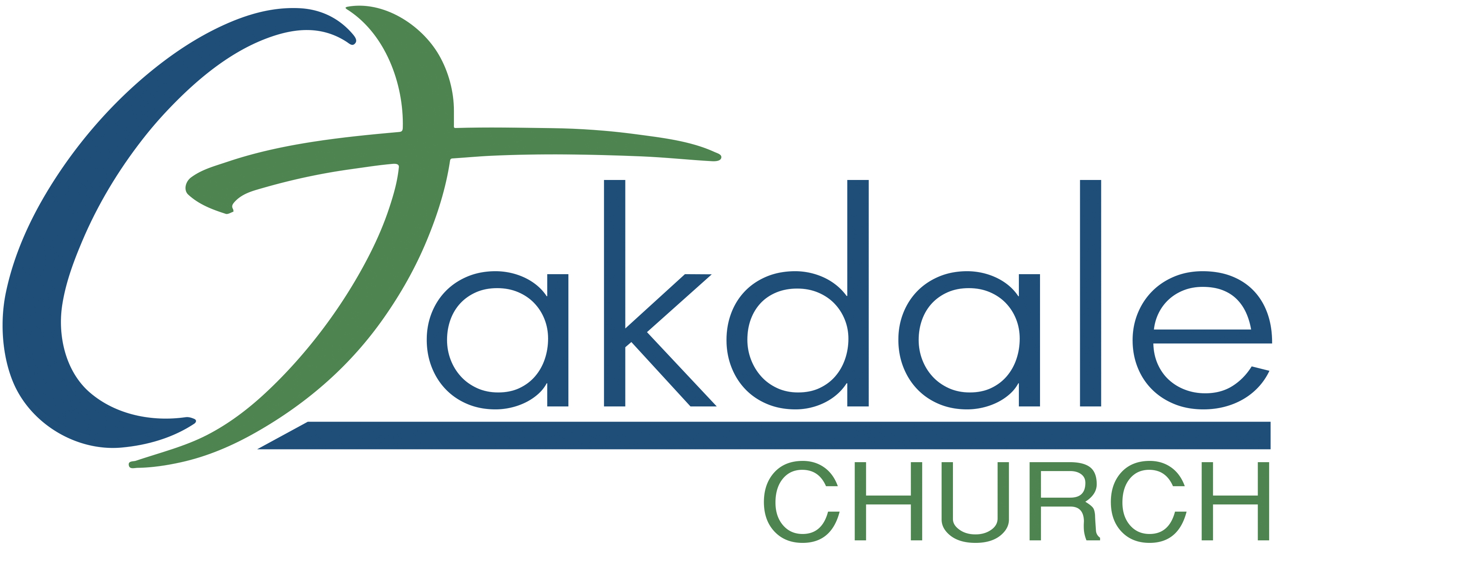
3425 Emory Church Rd, Olney, MD 20832
oakdale.church/cr
The Problem
Recovery is a two-fold process in this case. The first step is healing from the traumas done to us in our past, and the second step is healing from the influence these past experiences continue to have in our present lives.

(Most) Survivors of Physical / Sexual / Emotional Abuse…

• Are hesitant to identify themselves as victims of abuse.
• Feel isolated, depressed, worthless, and helpless to change.
• Are struggling with feelings about God in relation to their
life experiences of abuse.
• Condemn themselves, denying the past abuse affects their
present circumstances.
• Feel out of control and defeated in areas of compulsive
behavior.
• Feel angry, bitter, and rebellious; have trouble with
authority figures.
• Feel a lack of self-worth.
• Are preoccupied with thoughts of what it means to have a
“normal” relationship with others: mates, friends, family.
• Question their own sexual identity and may experience
confusion regarding their own sexuality.
• Desire to regain their sexuality and feel safe in intimate
relationships.
• Question self-reality: “Who am I?”
• Question whether life has a purpose.
• Feel “at home” in crisis situations.
• Struggle with perfectionism or “all or nothing thinking.”
• Desire to have victory

The Solution

Survivors of Physical / Sexual / Emotional Abuse can
experience recovery when…

• We recognize that we are powerless to heal the damaged
emotions resulting from our abuse. We look to God for the
power to make us whole.
• We admit that God’s plan for our lives includes victory over
the experience of abuse.
• We understand the people who abused us are responsible
for the abusive acts committed against us. We will not
accept the guilt and shame resulting from those abusive
acts.
• We look to God and His Word to find our identity as
worthwhile and loved human beings.
• We are honestly sharing our feelings with God and at least
one other person to help us identify the areas that need
cleansing and healing.
• We accept the responsibility for our responses to abuse.
• We are willing to accept God’s help in the decision and
the process of forgiving ourselves and those who have
perpetrated against us.
• We are willing to mature in our relationships with God and
others.
• We are willing to be used by God as an instrument of
healing and restoration in the lives of others.

* The Solution is partially based on the book Helping the Victims
of Sexual Abuse by Lynn Heitritter and Jeanette Vought.

