Small Group Guidelines
- Keep your sharing focused on your own thoughts, feelings, and actions. Please limit your sharing to three to five minutes.
- There is NO cross-talk please. Cross-talk is when two people engage in a dialogue during the meeting. Each person sharing is free to express feelings without interruptions.
- We are here to support one another. We will not attempt to “fix” one another.
- Anonymity and confidentiality are basic requirements. What is shared in the group stays in the group. The only exception is when someone threatens to injure themselves or others.
- Offensive language has no place in a Christ-centered recovery group.

Accountability Team Phone Numbers

Sponsor

Accountability Partners

© Celebrate Recovery®
Celebrate Recovery®

SUBSTANCE
DEPENDENCY

The Problem and Solution

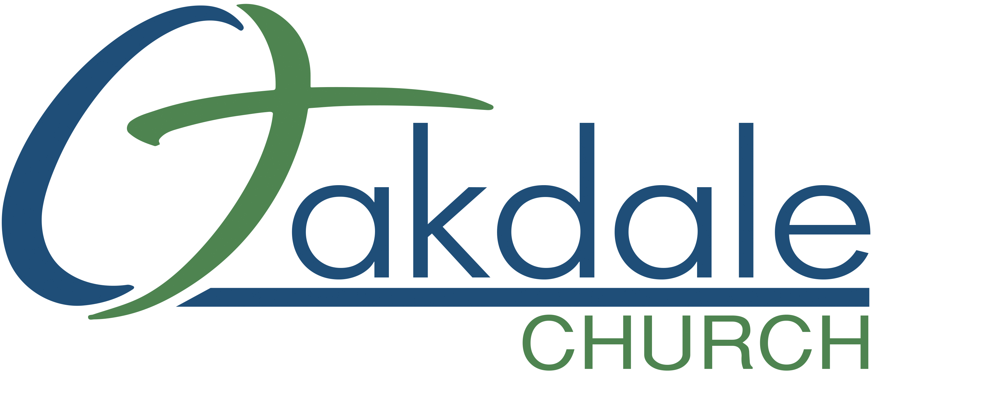
3425 Emory Church Rd, Olney, MD 20832
oakdale.church/cr

The Problem
When you are honest with yourself, do you find you cannot quit drinking, using drugs, gambling, shopping, using social media or technology for pornography or gaming entirely? Do you have little control over the amount you consume? You are probably an alcoholic and/or an addict.

Characteristics of someone struggling with substance dependency may include, but are not limited to:
- My addiction isolates me from people except when I am getting, using, and finding ways and means to get more.
- I have an inability to deal with life on life’s terms.
- I have tried any of the above substances listed or combinations of to find contentment in a seemly hostile world.
- I have dreamed of that magic formula that would solve my ultimate problem — myself.
- At times, I have been defensive about my addiction and justified my right to use, especially when and if I used legal prescriptions of technology for work related needs.
- I am trapped in the illusion of “just one more time.” Or “this time it will be different.”
- When I did seek help I was only looking for the pain to go away.
- My track record shows that it is impossible for me to use successfully.

The Solution
I will come to believe there is only one solution. I will accept Jesus Christ as my Higher Power and follow His plan for my life. I will work through the 8 Recovery Principles found in the Beatitudes. With Jesus Christ as my Higher Power, I can and will change!

We will learn how to:
- Live without drinking or using one day at a time with the help of the Higher Power, Jesus Christ.
- Stay away from that first use of whichever substance you are using. If there isn’t a first, there can’t be a 10th. And when free of your substance of choice, life becomes much more manageable.
- Experience the true peace and serenity you have been seeking.
- Restore and develop stronger relationships with God and with others.
- Stop relying on dysfunctional, compulsive, and addictive behaviors as a temporary “fix” for pain.
- Apply the biblical principles of conviction, conversion, surrender, confession, restoration, prayer, quiet time, witnessing, and helping one another.

I will also be willing to:
- Form an Accountability TEAM: Sponsor, Accountability Partners.
- Weekly attending the Open Share Group.
- Commit to a daily quiet time in the Celebrate Recovery Bible.
- Read about this area of recovery.
- Understanding the root of each core issue you identify with and become willing to experience grief, forgiveness, and acceptance.

As you draw closer to your Higher Power, Jesus Christ, you will learn how to apply the 8 Recovery Principles and 12 Steps, designed to guide you in this journey we call “Recovery.”

If you are diligent to provide willingness, integrity, consistency, and rigorous honesty, God will supply you with the courage, strength, and ability to take the necessary steps to gain freedom from unhealthy behaviors.

